ASSIGNMENT 2
FINAL LAB TASKS BY OM 2280156
COURSE CC

LAB 4

CoreServicesVnet Basic Configuration
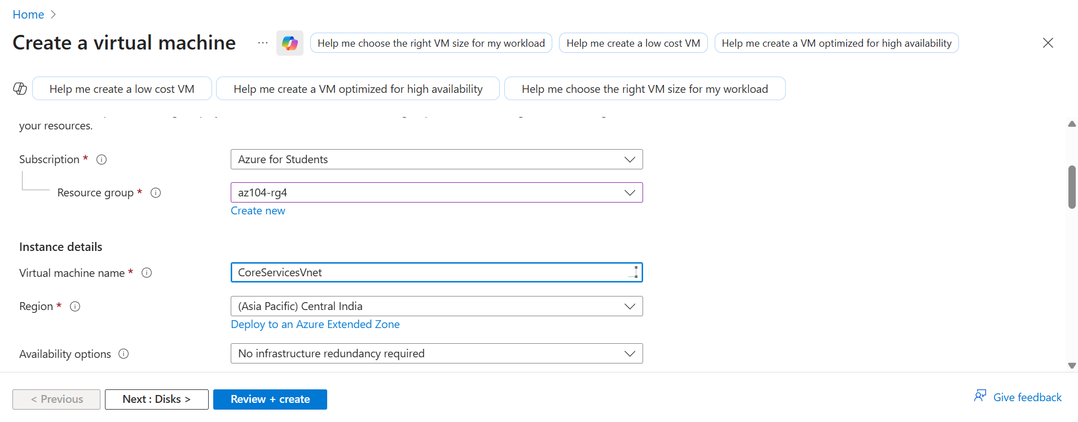

CoreServicesVnet Address Space Configured
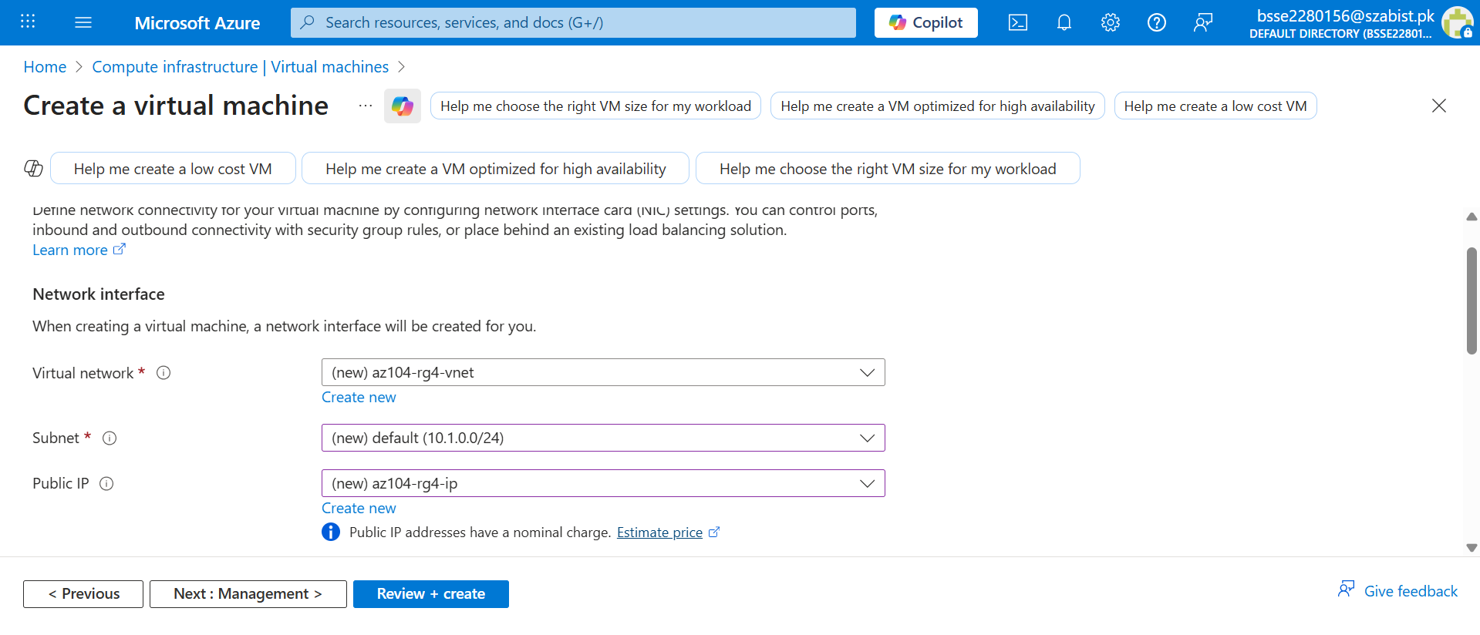
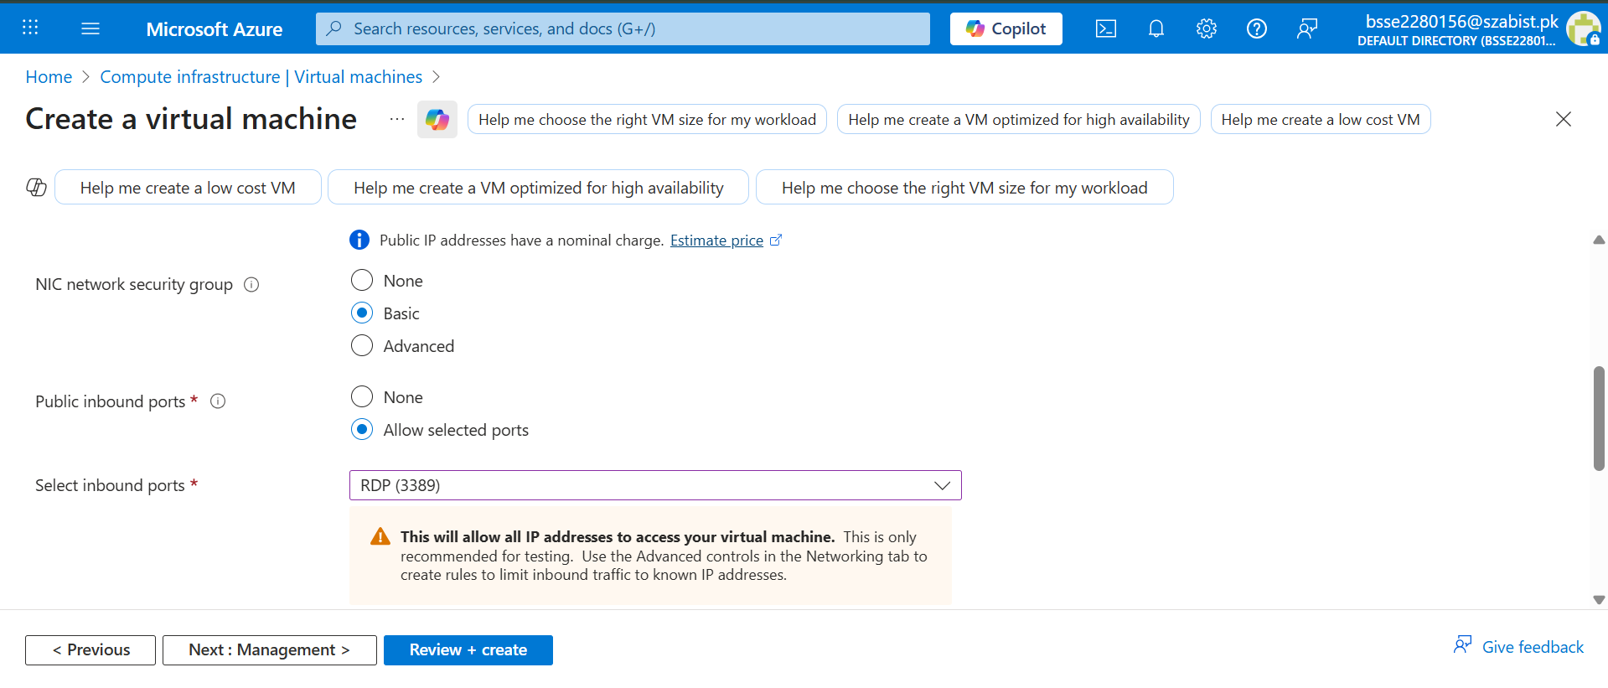

Virtual Machine Monitoring Configuration
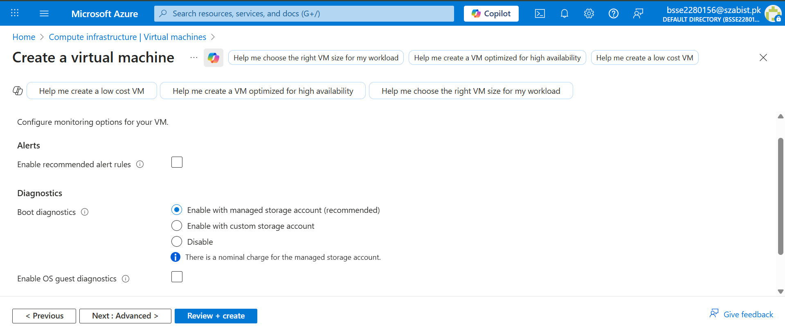

Virtual Machine Successfully Deployed
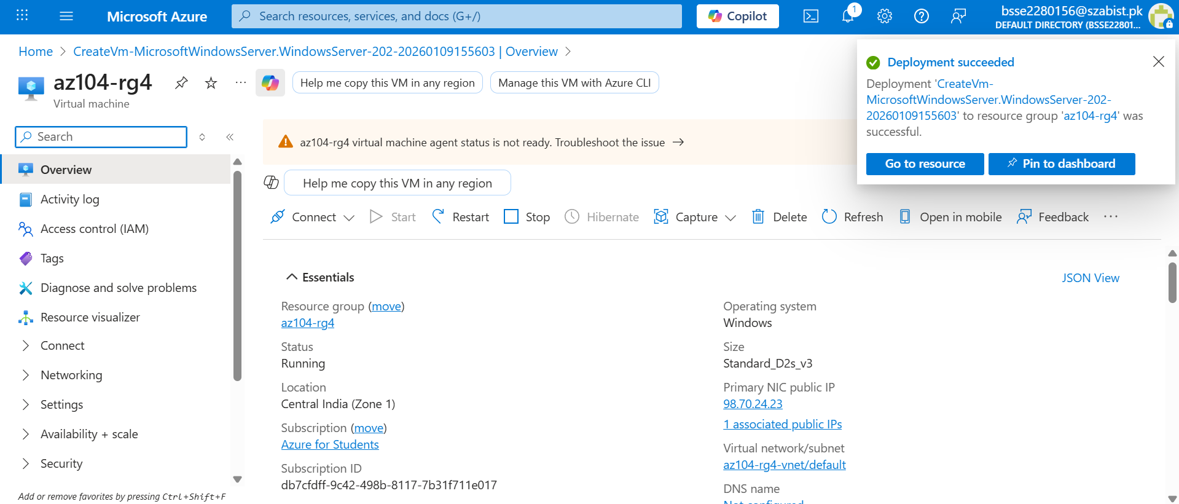

Virtual Machine Networking Overview
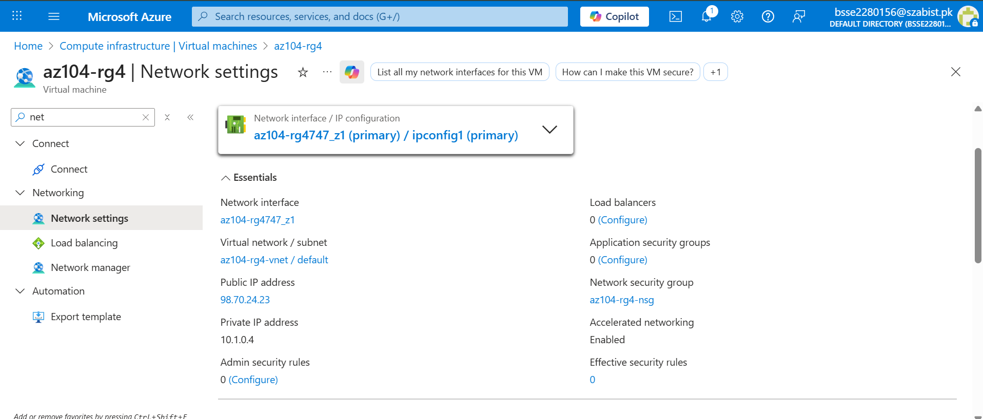
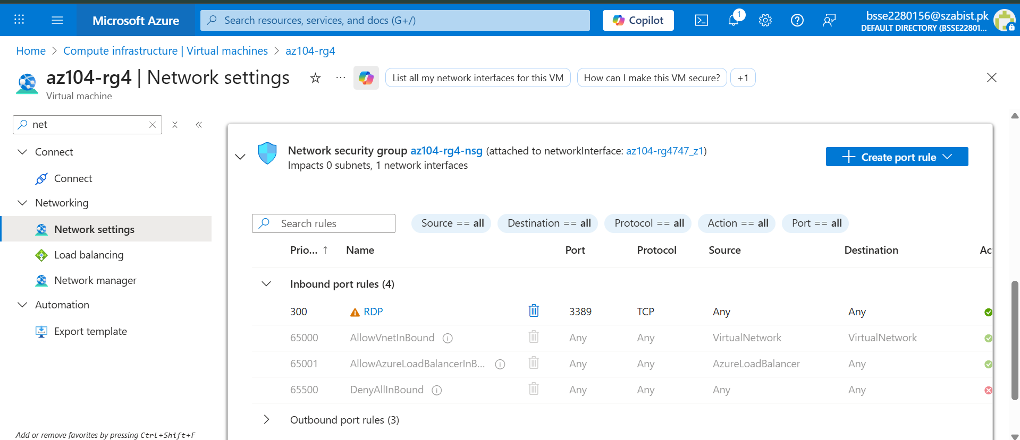

Inbound Security Rule for HTTP Traffic
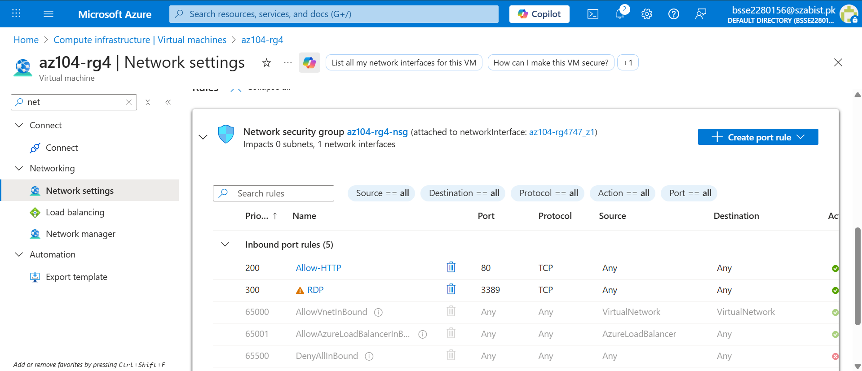

Virtual Network Resource Visualization
